Register for IBM cloud

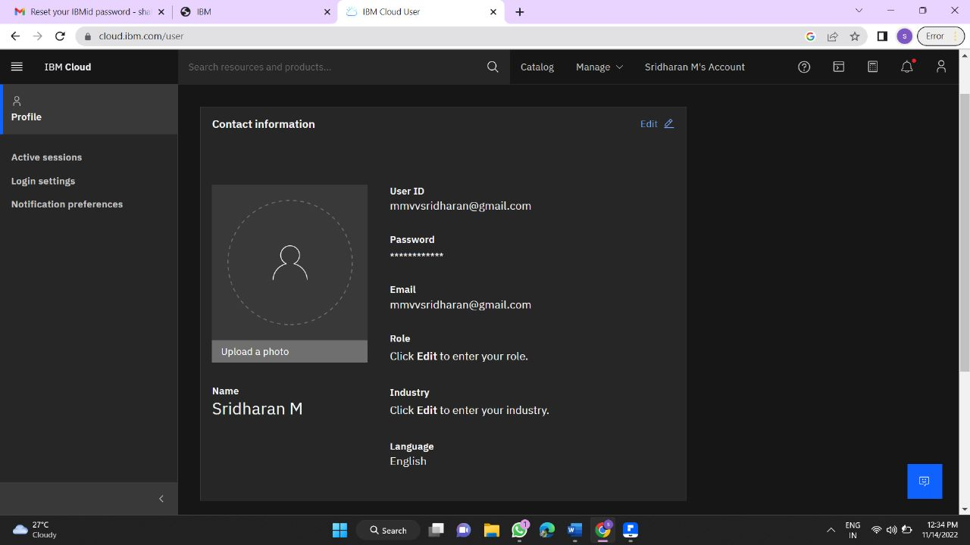M.SRIDHARAN